Name: Arun Sharma

Date: 08/18/2024

Assignment: Module 1.3 Assignment (Building a Web Page Exercise, Part 1) of (Module 1: Introduction to GitHub and HTML)

GitHub link: <https://github.com/SharmaArun017/csd-340.git>

Html Code:

<!DOCTYPE html>

<html lang="en">

<head>

<meta charset="UTF-8">

<meta name="viewport" content="width=device-width, initial-scale=1.0">

<title>CSD 340 Web Development with HTML and CSS</title>

</head>

<body>

<h1>Assignment 1.3 – Building a Web Page Exercise, Part 1</h1>

<p>I'm located in Seattle, and the weather today is 24 &deg;C and rainy. </p>

</body>

</html>

= Screenshots

1.

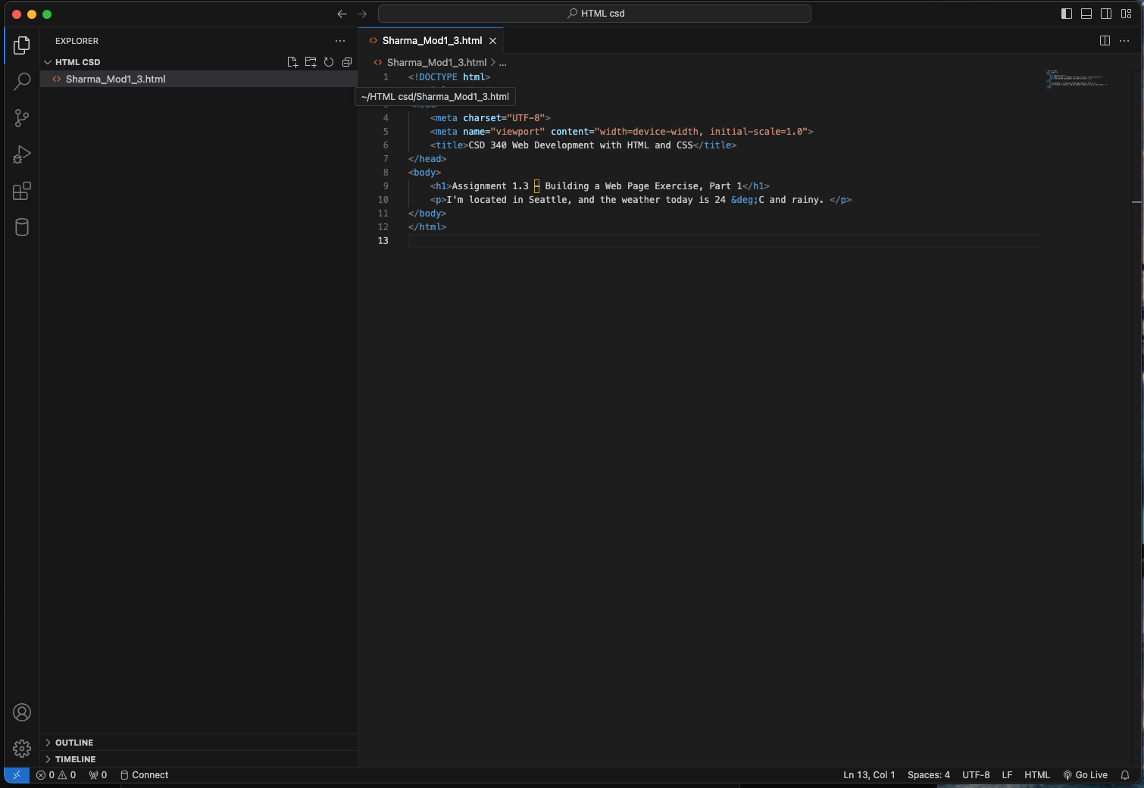

2.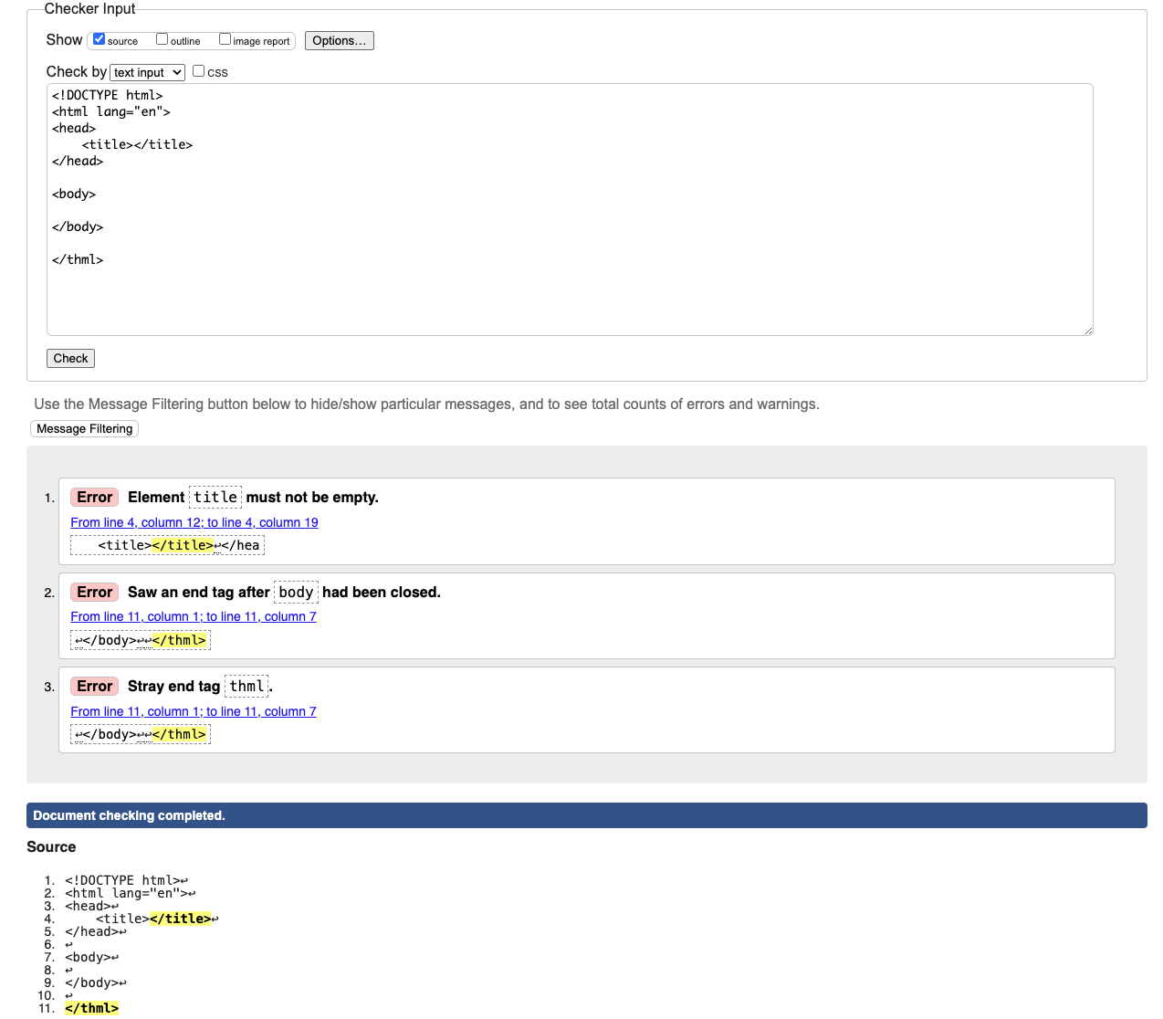

3.

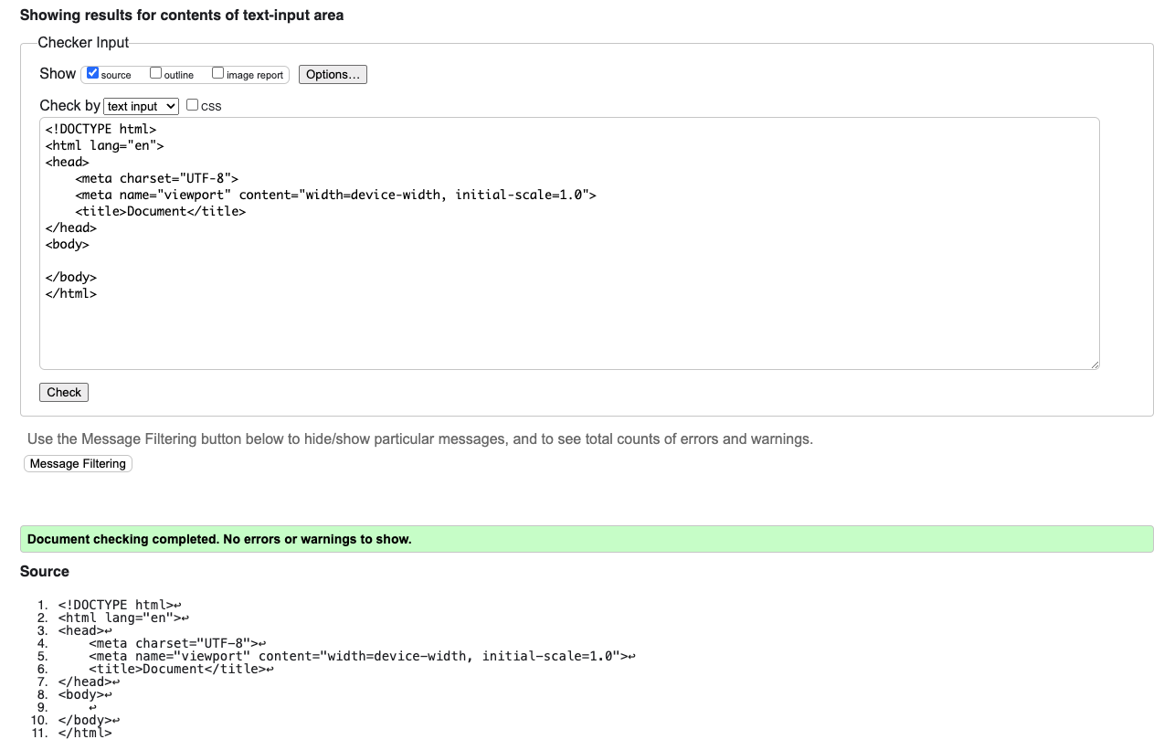

4.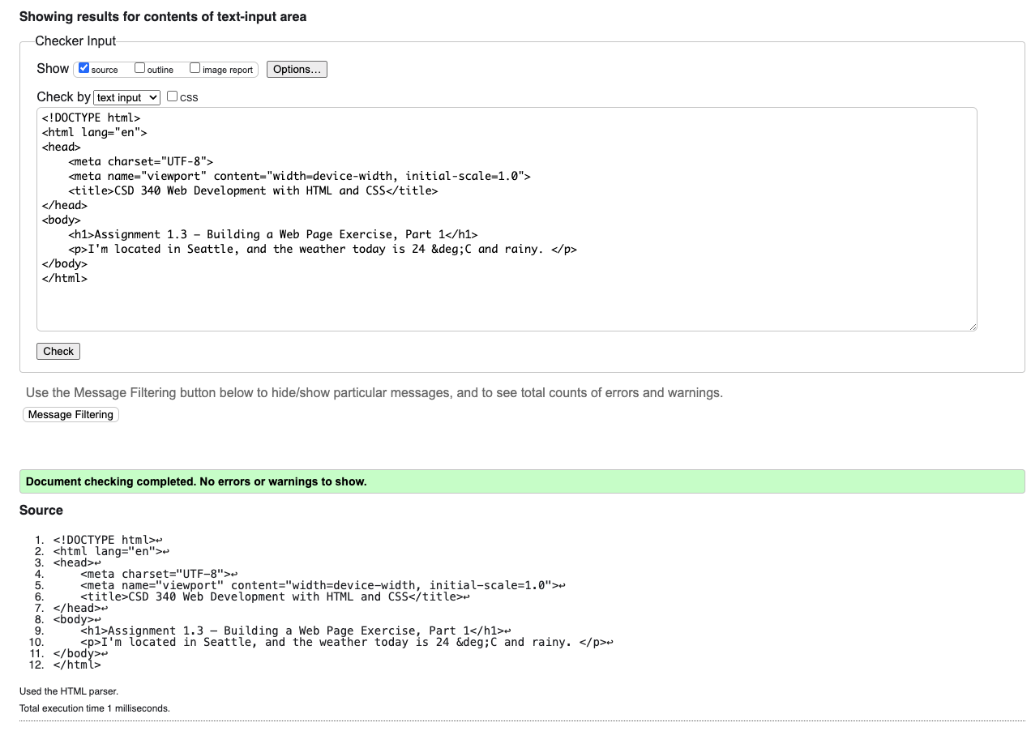

5.

